# **How to Outsource Product Manufacturing**

Outsourcing product manufacturing is contracting out a business's manufacturing process to a third-party service provider. This can include the entire production process or just a part of it, such as assembly or packaging.

This article serves as a comprehensive guide for businesses considering outsourcing product manufacturing. It includes benefits, steps, considerations, tips, and potential challenges designed to help make a well-informed decision.

## **Benefits of Outsourcing Product Manufacturing**

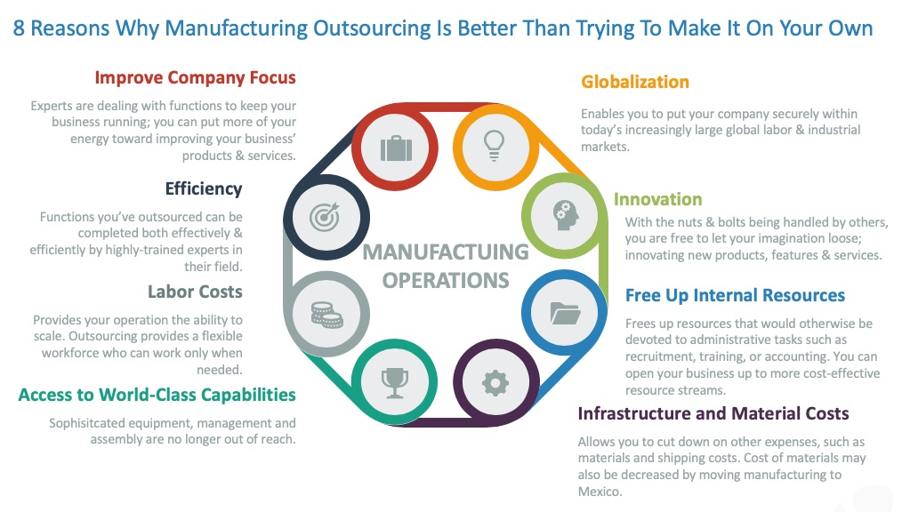

[Source](https://novalinkmx.com/wp-content/uploads/2020/01/June_25_Infographics_final.jpg)

### **Cost Savings**

Outsourcing manufacturing can be an incredibly effective strategy for businesses looking to streamline their production processes. Organizations can notably reduce labor costs and various operational expenses by choosing to outsource manufacturing to specialized manufacturing companies. This decision to collaborate with outsourced manufacturing companies eliminates the otherwise essential need for companies to invest in expensive machinery, intricate tools, and expansive facilities that would be required for in-house manufacturing. Such investments can be both time-consuming and financially burdensome.

Through outsourcing, these significant investments are handled by third-party experts, leading not only to an immediate reduction in costs but also to long-term financial savings. The flexibility provided by these savings allows businesses to reallocate resources to other vital areas, such as research, development, or marketing, thereby enhancing their overall competitiveness and success in the market. Therefore, engaging with outsource manufacturing companies can become a pivotal element in a company's growth strategy, emphasizing cost efficiency and optimized production.

### **Improved Customer Satisfaction**

By engaging in outsourcing production to skilled professionals and specialized contract manufacturing companies, businesses can achieve remarkable advantages in the efficiency and quality of their production line. Opting to outsource production processes to these experts not only brings industry-leading knowledge and experience to the table but also ensures adherence to the highest standards of quality. The attention to detail, mastery of technology, and optimized workflows provided by these contract manufacturing companies lead to a streamlined and highly efficient production line. As a result, products manufactured through this outsourced process often surpass standard quality benchmarks, leading to a final output that can exceed the most discerning customers' expectations. Enhanced customer satisfaction then follows as a natural consequence of this high level of quality and efficiency. By making the strategic decision to outsource production processes, businesses align themselves with excellence in manufacturing, creating a path that leads to stronger customer trust, loyalty, and overall success in the marketplace.

### **Access to a Larger Pool of Talent**

Outsourcing, particularly when engaging with a contract manufacturing organization, opens up vast opportunities for businesses to tap into a reservoir of global talent and specialized expertise that might otherwise be unattainable if they were to manufacture goods in-house. This vast network of professionals and experts offers unique insights and exceptional skills that are cultivated from various regions and industries around the world. A manufacturing company seeking to outsource can benefit from this talent pool, utilizing its specialized knowledge to enhance the quality and efficiency of production processes.

Moreover, looking beyond in-house capabilities and working with a contract manufacturing organization often leads to substantial cost reduction. This is achieved by leveraging the existing infrastructure, technology, and skills the outsourcing partner has already invested in. Rather than bearing the financial and logistical burdens of developing these resources internally, companies that choose to outsource can fast-track their growth, enhance the overall quality of their offerings, and simultaneously achieve significant savings.

In essence, the choice to engage with external experts instead of solely relying on manufacturing goods in-house provides a strategic avenue for businesses to access world-class talent and cutting-edge techniques while also realizing considerable financial benefits

### **Improved Efficiency**

With the decision to employ a contract manufacturer to handle the intricate details of production, businesses can delegate a significant portion of the responsibility associated with the manufacturing processes. This outsourced approach allows the internal teams to concentrate on what they do best, such as developing their core competencies, formulating strategic growth initiatives, and managing other essential business operations. With its expertise and capabilities, the contract manufacturer takes charge of the production line, overseeing the supply chain management and ensuring that everything runs smoothly and efficiently.

This streamlined approach to outsource production processes eliminates the need for the business to manage the day-to-day challenges of manufacturing, including the ongoing oversight of manufacturing costs, quality control, and logistics. As a result, internal resources can be reallocated to focus on value-added activities, such as research, innovation, marketing, and expanding market reach. This realignment of focus and resources, driven by the strategic decision to work with a contract manufacturer, not only leads to better efficiency within the organization but also cultivates an environment where creativity and growth can thrive.

By trusting specialized external teams with production and embracing an outsourced model, companies are better positioned to achieve their long-term goals, enhance their competitive edge, and foster a more dynamic and responsive business structure.

### **Scalability**

Outsourcing product manufacturing offers a versatile and adaptable approach to managing manufacturing operations, allowing for greater scalability in response to varying market demands. Unlike the traditional method of in-house manufacturing, which often requires substantial investment in equipment, staffing, and infrastructure, outsourcing provides the flexibility to adjust production levels efficiently. Whether a business faces a sudden surge in demand requiring a rapid increase in production, or encounters off-peak periods where scaling down becomes necessary, the decision to outsource facilitates these shifts seamlessly. The outsourcing partners, specialized in manufacturing operations, can adapt to changes quickly and efficiently, adjusting production costs according to the required output levels. This dynamic response ensures alignment with market trends and consumer needs and contributes to more effective cost management.By avoiding the need for significant investments in in-house resources, companies can control expenditures and allocate funds to areas that contribute to profitable growth.

Furthermore, this approach provides an opportunity to explore new markets and adapt to changes without over-committing resources. Ultimately, outsourcing manufacturing operations becomes a strategic tool in the business arsenal, providing the agility to respond to the ever-changing market landscape while supporting profitable growth and maintaining a lean and efficient operational structure.

### **Risk Mitigation**

Outsourcing also helps in mitigating risks associated with manufacturing. By relying on an experienced third-party provider, businesses can share responsibilities such as compliance with regulations, managing raw material fluctuations, and handling operational challenges. This distributes the risks and can lead to a more robust overall strategy.

### **Access to Advanced Technology**

Outsourced manufacturing partners often have access to cutting-edge technology and sophisticated manufacturing techniques that may not be readily available or affordable for a business to implement in-house. By tapping into this advanced technology, companies can benefit from innovative production methods and enhanced product quality without bearing capital costs.

## **Steps for Outsourcing Product Manufacturing Effectively**

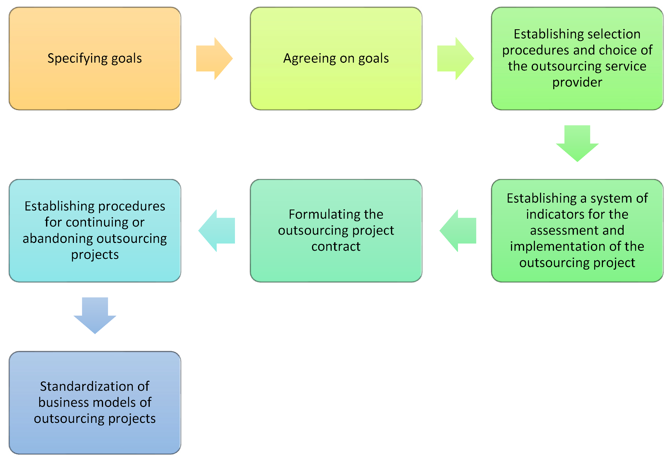

[Source](https://www.mdpi.com/resources/resources-11-00034/article_deploy/html/images/resources-11-00034-g004.png)

### **1. Define Your Customer Service Needs**

Grasping a clear understanding of your customer needs and expectations forms an essential cornerstone in the process of selecting the right outsourcing partner. Before embarking on the journey to find a suitable third-party collaborator, it is paramount to identify and define what exactly your customers require and anticipate. This insight goes beyond mere product specifications; it encompasses quality expectations, delivery timelines, after-sales support, and even the values that resonate with your target audience.

### **2. Research Outsourcing Options**

Investigate potential outsourcing partners, considering factors like reputation, expertise, technology, and compatibility with your needs.

### **3. Develop a Clear Communication Plan**

Establishing transparent communication channels ensures that both parties are on the same page.

### **4. Implement and Monitor the Outsourcing Process**

Implementing a comprehensive monitoring system is a valuable tool for tracking progress throughout various stages of a project or process. By consistently observing and assessing performance, this system allows for the timely identification of areas that may require improvement. It enables teams and management to gain an overview of ongoing activities, spot potential inefficiencies, and make data-driven decisions to enhance performance. This vigilant approach ensures alignment with goals and fosters a culture of continuous improvement and excellence.

### **5. Assess Legal and Compliance Requirements**

Understanding and complying with legal regulations is vital to conducting business, particularly when engaging in collaborative agreements or partnerships. Both parties must be keenly aware of and adhere to the relevant local and international laws governing their industry and operations. This includes understanding and ensuring compliance with complex legal frameworks such as intellectual property rights, labor laws, environmental regulations, and other pertinent legal standards. Such adherence not only safeguards the interests of all stakeholders but also establishes a foundation of trust and legitimacy in the business relationship, promoting smooth and lawful collaboration.

### **6. Determine Key Performance Indicators (KPIs)**

Identifying and setting clear Key Performance Indicators (KPIs) is essential in measuring and evaluating the success of an outsourcing relationship. These KPIs serve as tangible benchmarks that can be used to assess how well the partnership is performing to the agreed-upon objectives. They include critical factors such as quality standards, which ensure the product or service meets specific criteria; production timelines, which help track efficiency and timeliness; cost controls, which monitor financial aspects; and other relevant metrics. These KPIs provide a comprehensive overview of the collaboration's progress and effectiveness, enabling continuous improvement and alignment with business goals.

### **7. Select the Right Outsourcing Model**

Selecting the right outsourcing model is a strategic decision that requires careful consideration of various options, such as offshoring, nearshoring, or onshoring. The choice between these models should be made based on a thorough assessment of your specific business needs, budget constraints, and the desired level of control over the processes and operations. Each of these outsourcing models offers unique advantages and potential challenges, and understanding how they align with your company's objectives and resources will guide you in making a decision that best supports your overall business strategy.

### **8. Negotiate and Draft a Comprehensive Contract**

A well-structured contract is essential to protect both parties. It should include details on deliverables, timelines, quality control, conflict resolution, and termination conditions.

### **9. Create a Transition Plan**

If you're moving from in-house manufacturing to outsourcing, create a detailed transition plan to ensure a smooth shift. This plan should include timelines, responsibilities, and measures to mitigate potential disruptions.

### **10. Establish Regular Review and Feedback Mechanisms**

Implement a continuous review process with regular feedback sessions. This allows both parties to address any concerns and make adjustments as needed, fostering a collaborative and successful partnership.

## **Factors to Consider When Outsourcing Product Manufacturing**

### **Quality of Services**

Ensure that the outsourced partner you select not only meets but preferably exceeds your established quality standards. It's vital to identify a collaborator that aligns with your expectations and can consistently deliver products or services that adhere to the quality benchmarks set forth by your company, reflecting the values and reputation you wish to uphold.

### **Availability and Accessibility**

Consider time zones, language proficiency, and ease of communication with the outsourcing partner.

### **Cost**

Carefully analyze the cost-effectiveness of outsourcing by evaluating not only the immediate expenses but also including any hidden costs that may arise, as well as considering the long-term value and potential savings that outsourcing might offer. This comprehensive financial assessment ensures a well-rounded understanding of the economic implications and benefits of the outsourcing decision.

Cultural Compatibility

Assess the cultural alignment between your organization and the potential outsourcing partner to ensure a smooth working relationship. Understanding and respecting each other's values, communication styles, and working practices can foster a more cohesive and productive collaboration, minimizing misunderstandings and conflicts.

## **Tips for Successful Product Manufacturing**

### **Foster Open and Clear Communication**

Regular communication fosters trust and helps in addressing issues promptly.

### **Maintain a Consistent Brand Voice**

Ensure that the outsourcing partner understands and maintains your brand's identity and values.

### **Use Technology to Your Advantage**

Leverage technological solutions for collaboration, project management, and quality control.

### **Continuously Evaluate and Improve the Outsourcing Process**

Ongoing assessment ensures that the process stays aligned with business goals.

## **Potential Challenges of Outsourcing Product Manufacturing and How to Overcome Them**

### **Language Barriers**

Overcome language barriers by using common languages or professional interpreters.

### **Time Differences**

Plan regular meetings at mutually convenient times to ensure alignment and collaboration.

### **Maintaining Control Over the Customer Experience**

Establish clear guidelines and performance metrics to maintain control over quality and customer experience.

Outsourcing product manufacturing can lead to significant cost savings, improved customer satisfaction, access to specialized talent, and improved efficiency. Businesses can implement an effective outsourcing strategy by following the steps and considering essential factors.

## **Final Thoughts on Making a Successful Outsourcing Decision**

Outsourcing product manufacturing is a strategic decision that requires thoughtful planning, careful selection, and diligent management. Following the guidance provided in this article, businesses can navigate the complexities of outsourcing, aligning with organizational goals and maximizing success. If you are considering this path, closely examine The New Workforce.

Our dedicated expertise and commitment to excellence can help you achieve your goals when outsourcing product manufacturing, providing support every step of the way and delivering results that align with your unique needs and objectives. Trusting your outsourcing needs to The New Workforce can be a pivotal step towards unlocking new opportunities and driving your business forward.